2024
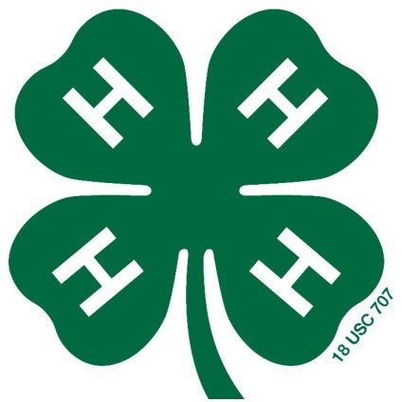
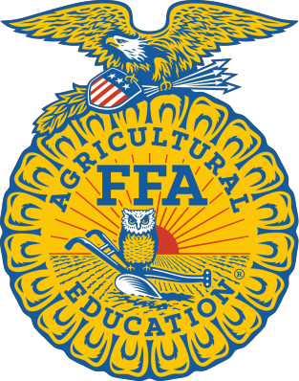
ANDERSON COUNTY BORN NOMINATION FORM
Fill out one form per animal entered in the Anderson County Born class for the Anderson County Fair.
Due with Fair pre -entries.

Circle the species being nominated below.
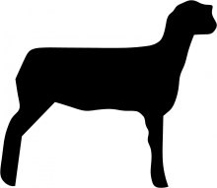
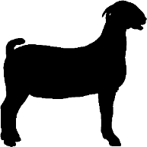
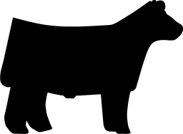
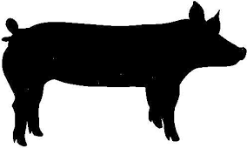
Beef Goat Sheep Swine

I , hereby nominate the market animal (Your Name)
(ear tag #) for the Anderson County Born class.
(Official Tag Number)

I am a current 4-H/ FFA member of .
(Club/Chapter Name)
This animal was born in Anderson County from a Dam owned by
.
(Owner Name)
,an Anderson County Resident.
(Address)
Signature of Owner of Dam

Signature of 4-H/FFA Member

Falsification of this document or information contained upon this document will result in disqualification of the 4-H/ FFA member and/or animal owner to participate in this class.
(02/2024)

